Accelerating Hyperparameter Optimization via Dataset Meta Features and Bayesian Search
Adarsh S K,Bhuvan R, Charan M
Department of Computer Science and Engineering BMSIT College

Abstract—Hyperparameter optimization (HPO) plays a cru- cial role in enhancing the performance of machine learning algorithms. Traditional techniques like grid search and random search involve searching across many different parameters; therefore, they are highly computationally intensive. On the other hand, Bayesian optimization offers an improvement by employing probability-based methods to guide the search process, albeit requiring several iterations.
This project focuses on optimizing hyperparameters through a dataset-aware technique using meta-learning. This technique uses dataset attributes, commonly called meta-features, to determine optimal hyperparameters for machine learning models.
Meta-features such as the number of samples, number of classes, skewness of distribution, and class entropy are used to form feature vectors. These feature vectors are input into a gradient boosting regressor trained on data generated by applying Bayesian optimization to various datasets.
Once trained, the meta-learning algorithm generates hyperpa- rameters for new datasets based on their meta-features, reducing the number of times the HPO algorithm needs to run.
In this study, the meta-learning technique will be applied to several datasets, and its efficiency and effectiveness will be assessed against Bayesian optimization.
Results reveal that the meta-learning model performs as effectively as Bayesian optimization while generating predictions for only one trial.
- Introduction
The application of machine learning technology is now widespread in various applications from classification to pre- diction, recommendation systems to data analysis. The ef- ficiency of machine learning algorithms is determined not only by their choice but also by choosing hyperparameters which are specific parameters that define machine learning models before their training process. Hyperparameter values can include the number of estimators in ensemble models, learning rate, and maximum tree depth, among other values.
Selecting optimal hyperparameters is not a trivial task be- cause traditional methods used to achieve this purpose usually involve evaluation of a number of possible combinations of these parameters. The grid search method includes trying out all possible combinations in a predetermined parameter range. As compared to the grid search approach, the random search method involves random sampling of possible combinations. However, both approaches are resource-intensive and time- consuming.
The Bayesian optimization method represents an alternative solution, which models the target function and chooses hy- perparameters according to previous evaluations. While being
more efficient in comparison to other optimization algorithms, this method is still an iterative one that needs several trials to produce optimal or almost optimal results.
However, in practice, we do not always have sufficient time and computational power to perform hyperparameter optimization iteratively. Moreover, for each new dataset, it would be unproductive to use such approaches for finding optimal parameters. This is why there are approaches that aim at reducing the amount of searching needed or even completely avoiding the need for it.
The fundamental principle of applying meta-learning here lies in the fact that the similarity of datasets implies the necessity of similar parameter settings. In this regard, it is possible to extract features from datasets and use them to discover regularities in relationships between the properties of datasets and their hyperparameter tuning requirements. The found patterns will help us predict appropriate hyperparame- ters for other datasets.
For our case study, we have developed an approach based on combining Bayesian optimization with meta-learning. First, using Bayesian optimization, we find good hyperparameters for a group of several datasets. Then, we create a meta-learning algorithm that maps meta-features to hyperparameters. For this purpose, we decided to employ a Gradient Boosting Regressor. Once the model is fitted, it will allow predicting parameters for other datasets.
Our primary goal is to show that it is possible to obtain results similar to the outcomes of conventional optimization approaches while reducing computational costs dramatically. In this way, we will contribute to the development of more efficient automated machine learning algorithms.
- Problem Statement
Hyperparameter optimization is an important stage in devel- oping high-performing machine learning algorithms. It plays a key role in enhancing the effectiveness of machine learning algorithms such as Random Forest, Support Vector Machines, and Neural Networks. Nevertheless, finding optimal hyper- parameters is a difficult task as it entails conducting many experiments.
Classical methods including grid search and random search try to find an answer by testing different sets of parameters. Although both approaches are effective, their performance suffers due to the extensive computational cost. Bayesian Opti- mization is one of the state-of-the-art techniques that are more

effective than classical methods in terms of computational cost; however, the process of convergence still takes many iterations.
In real-life applications, particularly when dealing with mul- tiple datasets or limited resources, repeating hyperparameter optimization is not efficient. A way of minimizing the reliance on iterative optimization procedures while keeping the model’s performance unchanged is needed.
The problem solved by this project is the creation of an algorithm that predicts optimal hyperparameters depending on the characteristics of a dataset, which allows one to minimize the number of iterations in finding the solution without sacri- ficing the accuracy of machine learning models.
- Objectives
The key objectives of this project include the following:
- Designing a data set-aware hyperparameter optimization system employing meta-learning algorithms.
- Extracting useful meta-features from the data set, includ- ing its size, feature dimension, class distribution, and statistical attributes to describe distinct data sets.
- Employing Bayesian optimization (Optuna) to obtain optimal hyperparameters for various data sets, which act as ground truth for learning.
- Training a meta-learning model using Gradient Boosting Regressor to discover the connection between data set meta-features and optimal hyperparameters.
- Predicting optimal hyperparameters for new data sets using the meta-learning model and decreasing repetitive optimization procedures.
- Comparing the accuracy of predicted hyperparameters with that of optimized hyperparameters.
- Decreasing computational expenses by reducing hyperpa- rameter optimization iterations while ensuring equivalent performance.
- Methodology
The designed pipeline is made up of two components: hyperparameter optimization and meta-learning, both of which together constitute the learning process. The main idea behind this design approach is learning the mapping from datasets to hyperparameters for future optimizations.
- Dataset Selection
To ensure diversity, three datasets with different character- istics are used in this project:
  - Iris dataset – This is a small dataset characterized by low dimensionality and class balance.
  - Digits dataset – This is a relatively large dataset with high dimensionality and multiple classes.
  - WineQT dataset – This is an intermediate-sized dataset with class imbalance.
The use of datasets with different characteristics will enable the model to detect patterns from different kinds of datasets.
- Meta-Feature Extraction
For every dataset, meta-features are calculated and used in the meta-learning process. These meta-features describe the properties of the dataset used. The features used include:
  - Number of samples – denotes the size of the dataset.
  - Number of features – denotes the dimensionality of the dataset.
  - Number of classes – denotes classification difficulty.
  - Class imbalance ratio – shows variation in data distribu- tion among classes.
  - Mean of features – shows statistical property of feature values.
  - Standard deviation of features – shows dispersion of data.
In order to prevent any outlying value from influencing the training process, the imbalance ratio is first scaled through logarithmical transformation. Moreover, normalization is done to standardize features.
These meta-features act as the condensed form of the entire data set. They enable the model to detect correlations between the characteristics of the data set and its best hyperparameters.
- Optimizing Hyperparameters using Bayesian Search
The process of optimizing hyperparameters via Bayesian approach is performed using the Optuna package. Unlike other search methods like grid search and random search, Bayesian search works based on a probabilistic model.
For the Random Forest classifier, the following hyperparam- eters will be optimized in this project:
  - The number of estimators (trees)
  - The maximum depth of trees
Tree-structured Parzen Estimator (TPE) is selected as the algorithm to run on top of Optuna. It models the objective function and selects the best configuration using the acquisi- tion function.
Stratified K-Fold cross-validation is utilized in order to have a consistent evaluation of the model performance with regard to the data stratification and thus provide more reliable results. The output of this stage is the optimal hyperparameters for each dataset, which will be used later as target variables for
meta-learning.
- Meta-Dataset Construction
Having found the optimal parameters for each dataset, the next step is to build the meta-dataset. Its structure includes:
  - Meta-features for each dataset
  - Optimal hyperparameters corresponding to each dataset
- Meta-Learning Model
Gradient Boosting Regressor acts as the meta-learning model. Two models are built separately:
  - One model predicts the number of estimators
  - Another one predicts the maximum depth
The Gradient Boosting method is utilized due to its effec- tiveness on tabular data and the ability to establish nonlinear

dependencies. Models are created in sequence, where each successive model attempts to reduce errors of previous models.
Model training takes scaled meta-features as input data and optimized hyperparameters as target features.
- Prediction Phase
After training, the model is employed for predicting optimal hyperparameters for some particular dataset. The algorithm consists of the following steps:
- Calculation of meta-features from the dataset
- Feature scaling based on previously calculated transfor- mations
- Prediction of hyperparameters based on features ob- tained after scaling
Predicted values are used as optimal hyperparameter values directly to train machine learning models.
- Evaluation Method
The performance of the proposed method can be determined by the following comparisons:
  - Predicted hyperparameter training model accuracy
  - Optimized hyperparameter training model accuracy
  - Trials per method
This method shows the effectiveness and efficiency gained by the proposed system.
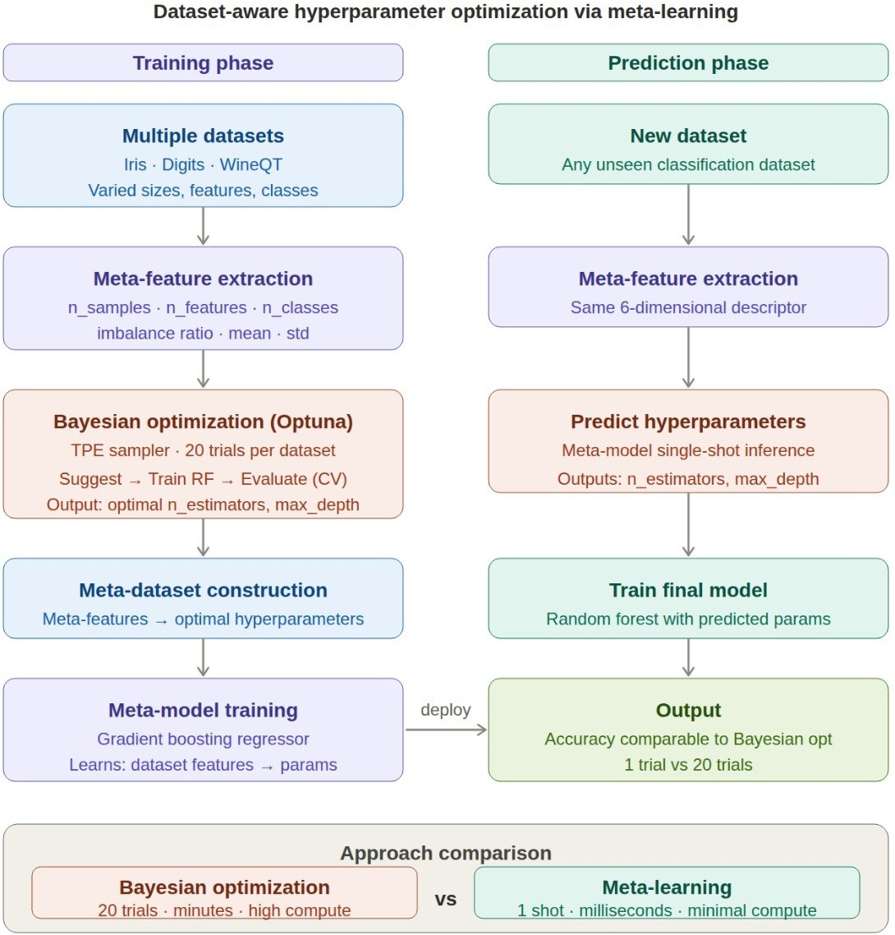

Fig. 1. Overall workflow of dataset-aware hyperparameter optimization using meta-learning

- Related Work
Hyperparameter optimization is a popular subject in ma- chine learning due to its direct effect on the performance of the models. Such popular methods as grid search and random
search are known for their simplicity but are not very efficient in terms of the number of iterations needed to optimize hyper- parameters. Grid search checks all possible configurations of parameters within certain ranges, while random search chooses hyperparameters randomly.
However, more sophisticated approaches have appeared in order to solve problems of inefficiency caused by the increas- ing complexity of search spaces. For example, Bayesian op- timization relies on building probabilistic models of objective functions, which helps identify most promising configurations and reduce the number of iterations needed. There are several frameworks that allow using Bayesian optimization, among them are Optuna and Hyperopt.
Recently, researchers have started to pay attention to meta- learning approaches to hyperparameter optimization. Such approaches utilize previously obtained information about other datasets in order to optimize hyperparameters and achieve improved performance on current tasks. Instead of starting the search procedure from scratch, meta-learning methods attempt to find initial parameters based on features of the dataset.
A number of works investigated the use of information about dataset size, its structure, and other meta-characteristics like class balance for tuning algorithm parameters. This ap- proach usually involves the combination of meta-learning with optimization algorithms in order to achieve higher quality. Some papers propose using meta-learning for initializing Bayesian optimization, while others try predicting optimal hyperparameters using regression and neural networks.
However, current state-of-the-art methods typically require big datasets and complex algorithms that makes it difficult to apply them in smaller scale tasks. Therefore, in our research, we decided to use a straightforward combination of a simple meta-learning scheme with a Gradient Boosting Regressor. This allowed us to show that hyperparameters can be effec- tively predicted using very few data.
In general, recent results indicate the importance of decreas- ing the cost of hyperparameter tuning task. That is why the application of meta-learning seems to be quite promising. This idea has been used in the course project as well.
- Algorithms Used
The project utilizes two main algorithms. These include Gradient Boosting Regressor for the purpose of meta-learning and Bayesian Optimization (with Optuna) for hyperparameter tuning. Each of the selected algorithms is chosen according to the appropriateness for the given task.
- Gradient Boosting Regressor
Gradient boosting is an ensemble machine learning algo- rithm that constructs a strong prediction model out of several weak learners such as decision trees. The construction of the model is sequential in nature since each newly constructed learner tries to reduce the errors of the previous learner.
In regression analysis, Gradient Boosting reduces the differ- ence between the actual and predicted results by minimizing a loss function. It is especially useful when working with

structured tabular data containing complex nonlinear relations between inputs and outputs.
In the current project, Gradient Boosting Regressor is im- plemented as the meta-learning algorithm. Its inputs are meta- features of datasets, while the outputs are hyperparameters that should be estimated. There are two models that predict two different hyperparameters – number of estimators and max depth.
The key reasons to use Gradient Boosting Regressor are:
  - Performs well on small and medium datasets.
  - Capable of handling nonlinearity.
  - Robust to noise and does not need much data.
  - Generates stable predictions rather than those of more complicated models.
- Bayesian Optimization (Optuna)
Bayesian optimization is an effective approach to optimizing costly objective functions without the need to evaluate all pos- sible combinations of hyperparameters. It uses a probabilistic model of the target function to find the best hyperparameter combinations.
In this project, Bayesian optimization is performed using the Optuna library, which employs the Tree-structured Parzen Estimator (TPE). The core idea behind TPE is modeling probability distributions of good/bad configurations of hyper- parameters and selecting the next hyperparameters according to them.
A typical cycle of bayesian optimization consists of the following actions:
- Proposing hyperparameter combinations.
- Training the model.
- Checking its performance via cross-validation.
- Updating the probabilistic model.
The procedure is iterated a few times to get better estimates of hyperparameters.
The rationale behind Bayesian Optimization includes the following features:
  - It is not necessary to perform more evaluations than with Grid Search and Random Search methods.
  - The method effectively strikes the balance between ex- ploration and exploitation.
  - It is suitable for tuning expensive machine learning algorithms.
- Random Forest Classifier
The machine learning algorithm selected as the base one in the course of the present project is the Random Forest Classifier. This approach involves the creation of a large ensemble of decision trees in order to increase the overall efficiency.
Bayesian optimization is implemented in order to select optimal values of hyperparameters such as the number of esti- mators and max depth. Afterwards, these values are predicted by the Meta Learning model.
Random Forest is preferable since it has the following advantages:
  - It shows good results in most cases.
  - It is difficult for it to overfit as compared to simple decision trees.
  - It can be applied to small and large datasets.
- Experimental Setup
In this section, we will talk about the environment, datasets, and configurations that were used to apply our suggested method.
- Software and Tools
The application of our model is done with the help of Python because of its excellent machine learning library support. The following libraries and tools are used in this work:
  - Scikit-learn - used to develop machine learning algo- rithms like Random Forest and Gradient Boosting Re- gressor.
  - Optuna - used to perform hyperparameter optimization through Bayesian optimization.
  - NumPy and Pandas - used for data manipulation.
  - Matplotlib - used to visualize the results.
- Datasets Used
We have selected three datasets with various characteristics to apply our model to them:
  - Iris Dataset – a small-sized balanced dataset with 150 samples and four features.
  - Digits Dataset – a relatively large-sized unbalanced dataset with 1797 samples and 64 features.
  - WineQT Dataset – an average-sized unbalanced dataset with 1143 samples.
- Base Model Hyperparameter Configuration
A Random Forest classifier is chosen as the base model, and the following hyperparameters will be optimized:
  - Number of estimators
  - Maximum depth
The values will be chosen from the reasonable range for these hyperparameters.
- Optimization Process
The Bayesian optimization with Optuna and Tree-structured Parzen Estimator sampling strategy is applied. Each dataset goes through 20 trials of the optimization process.
Stratified K-Fold cross-validation is used, and 5 splits are made. It ensures that the proportion of classes is similar between train/validation sets.
- Meta-learning Model Configuration
As the method for meta-learning, the Gradient Boosting Regressor is employed. It trains two models:
  - For predicting the number of estimators
  - For predicting the maximum depth
Prior to the learning process, meta-features are normalized.

- Criteria for Performance Evaluation
The following criteria are used to evaluate the performance of the suggested system:
  - Accuracy of the model through the predicted hyperpa- rameters.
  - Comparing this accuracy with the one gained through Bayesian optimization.
  - Decreasing the number of iterations involved in hyperpa- rameter optimization.

- Results and Analysis

The performance of meta-learning based hyperparameters’ prediction is compared with the performance of Bayesian Optimization technique based on the following three criteria: the accuracy of prediction, the number of trials needed, and similarity of the predicted and optimal values of the hyperpa- rameters.

- Accuracy Comparison
First, the accuracy attained using the predicted hyperpa- rameters was compared with the accuracy acquired using the Bayesian Optimization method. As seen from the table below, there is almost no difference between the accuracy obtained via two methods.
When the Iris dataset is used, the obtained accuracy via Bayesian Optimization is about 0.97. At the same time, the meta-learning model produces almost identical accuracy. In case of Digits dataset, both methods result in the accuracy close to 0.98. Finally, WineQT data yields relatively low accuracy (0.65). This can be explained by an imbalanced dataset used.
The above results prove the effectiveness of the predicted hyperparameters.

TABLE I
Comparison of Hyperparameter Optimization Methods

Dataset | Method | Accuracy | Trials
Iris  Iris | Bayesian Optimization  Meta-Learning | 0.97  0.97 | 20  1
Digits  Digits | Bayesian Optimization  Meta-Learning | 0.98  0.98 | 20  1
WineQT  WineQT | Bayesian Optimization  Meta-Learning | 0.65  0.65 | 20  1

The comparison in terms of accuracy demonstrates that the performance level attained via meta-learning and that attained through Bayesian optimization is almost equal. In the cases of Iris and Digits datasets, there are very high accuracy values for both optimization techniques, implying that the suggested hy- perparameters work effectively. Although the WineQT dataset does not have good accuracy levels because of the complexity and imbalance of the dataset, there is an equal performance level by the two algorithms.

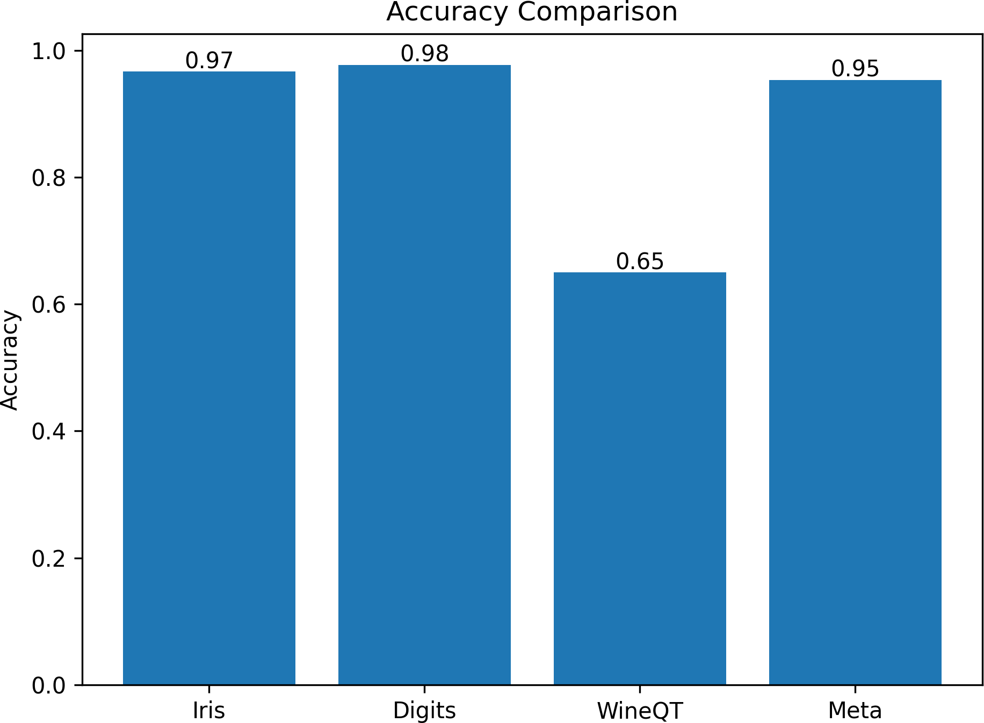

Fig. 2. Accuracy comparison between Bayesian optimization and meta- learning
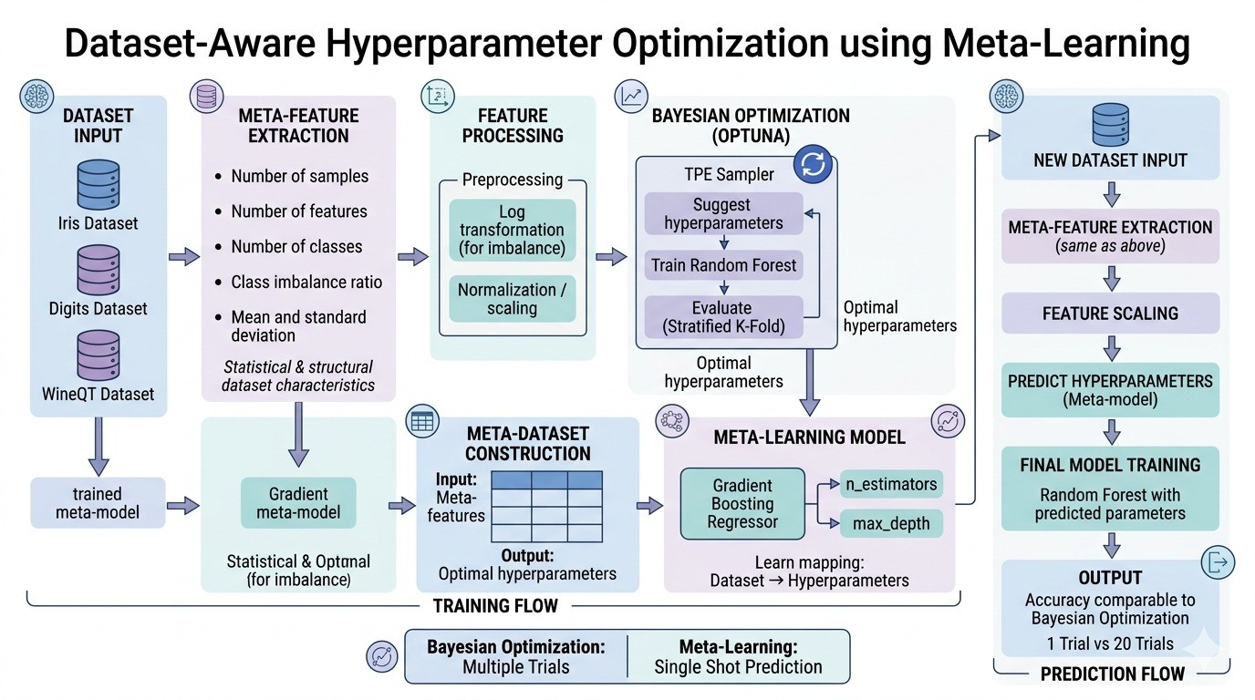

Fig. 3. Detailed architecture of the proposed meta-learning based hyperpa- rameter optimization system

- Trials Comparison
Reducing the cost involved in tuning of hyperparameters is one of the key aims of this project. The Bayesian optimization approach requires several trials to identify optimal hyperpa- rameters. The approach employed in this work uses 20 trials per dataset.
On the other hand, the proposed meta-learning technique does not need iterations. Instead, the model predicts the hyperparameters in one step. It reduces the number of trials from 20 down to just 1.
It is evident that this technique is highly efficient and can save a lot of time and effort in cases where iteration becomes difficult.
The comparison between the trials shows how efficient the suggested method is. For the Bayesian optimization, there need to be several trials (20 trials in this study) to determine proper parameters. However, the meta-learning model can determine parameters at once. Therefore, the use of this model leads to considerable time savings.
- Hyperparameter Comparison
Comparison of predicted hyperparameters with the optimal values is another way of validating the efficacy of the ap- proach.

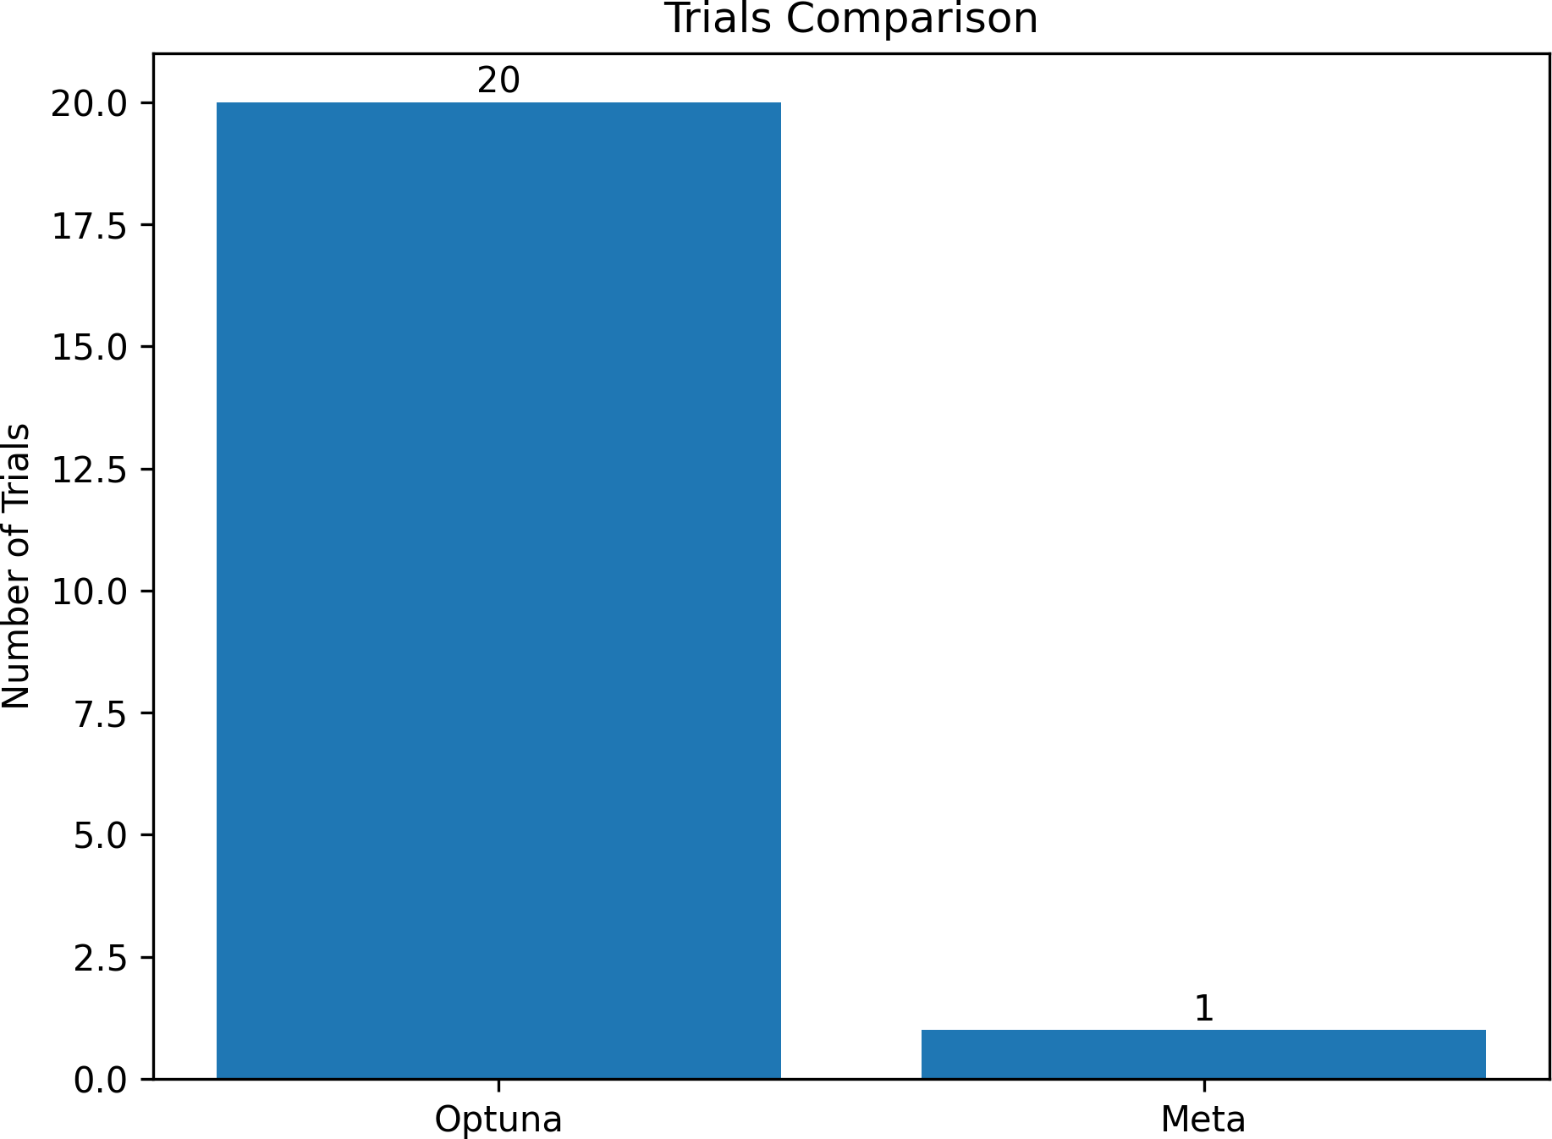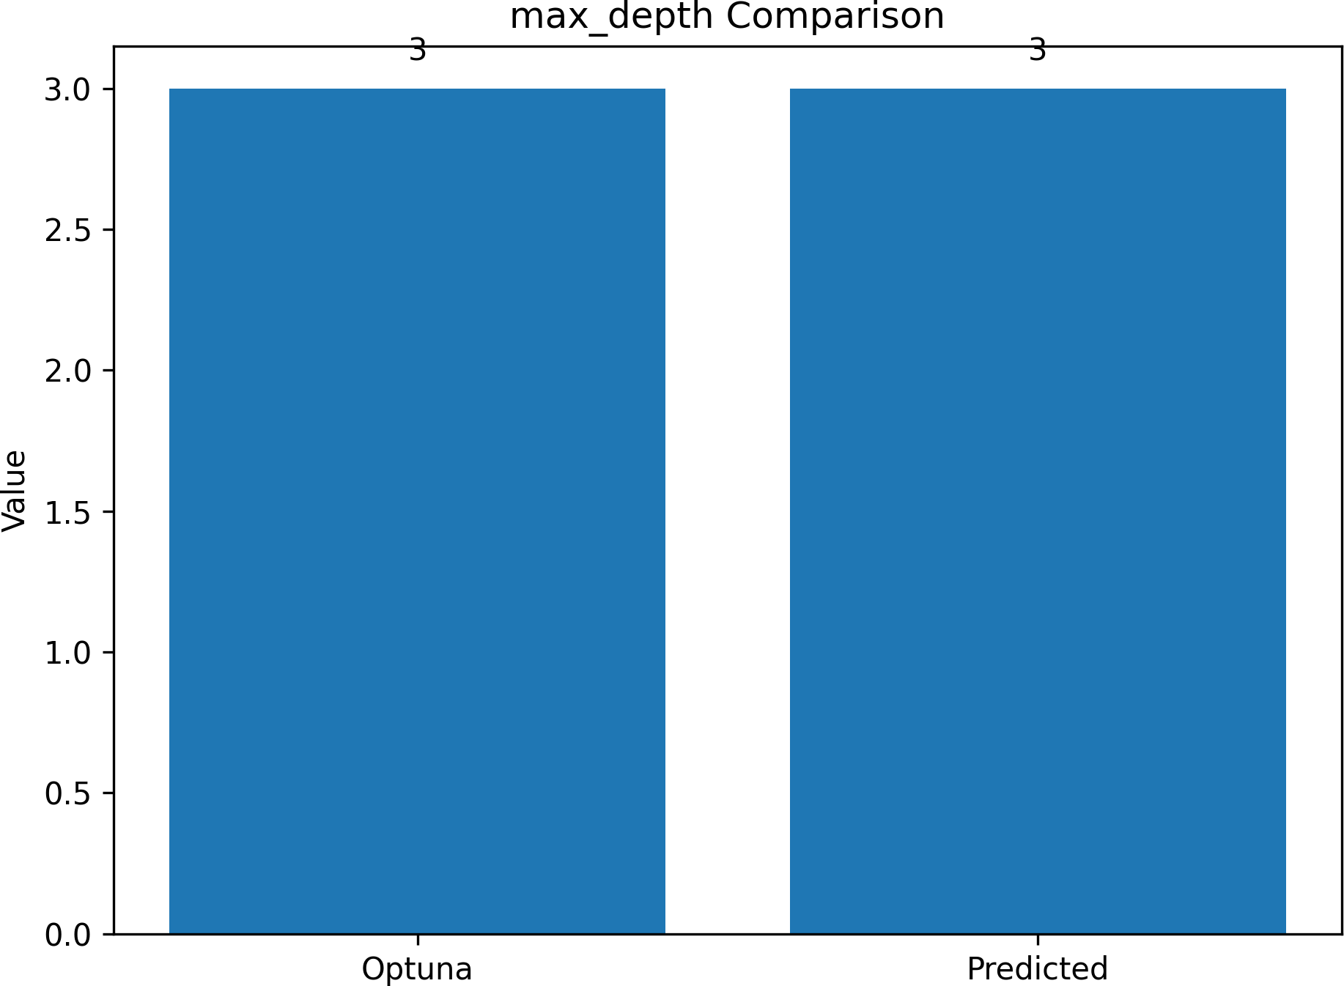

Fig. 4. Comparison of number of trials required

The Iris dataset yielded the same optimal number of esti- mators and maximum depth of tree for both approaches. The hyperparameters predicted by the model were the same as those optimized through Bayesian approach.
This implies that the model was successful in learning the connection between characteristics of the datasets and the optimum hyperparameters.

TABLE II
Hyperparameter Comparison for Iris Dataset

Parameter | Optuna | Meta-Learning
n estimators | 80 | 80
max depth | 3 | 3

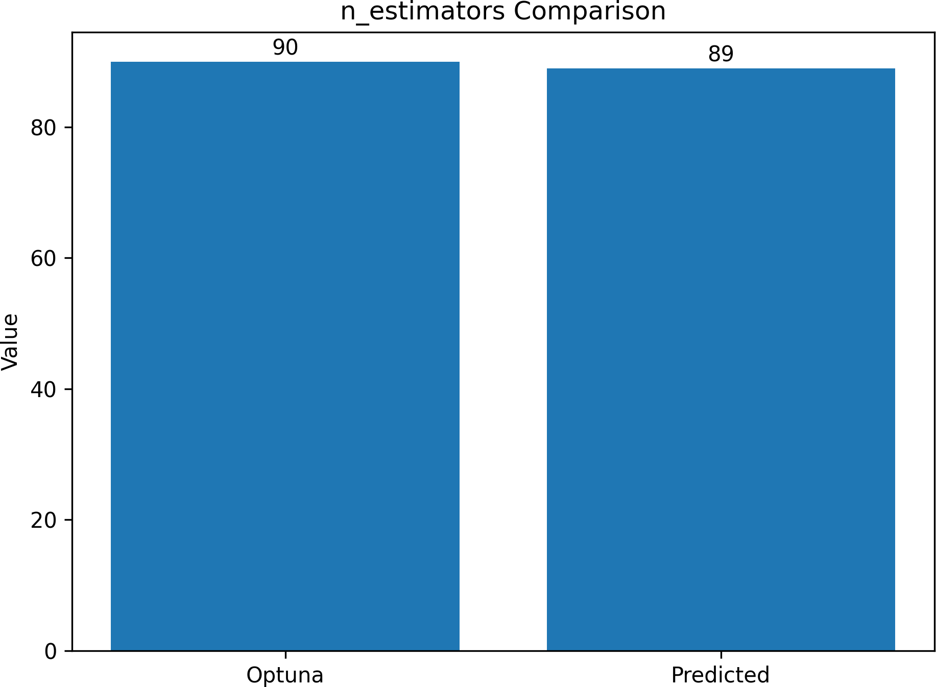

Fig. 5. Comparison of predicted and optimized number of estimators

The comparison of the numbers of estimators reveals that the predicted value is equal to the optimized one that was received via Bayesian optimization. It means that the meta- learning approach successfully acquired knowledge about the impact of features of the dataset on the given hyperparameter. A comparison of the maximum depth reveals that the predicted depth is exactly the same as the optimized depth. This further proves the efficiency of the proposed learning technique because the model was able to successfully identify
Fig. 6. Comparison of predicted and optimized maximum depth

connections between different features of the dataset and the model.
- Overall Analysis
From the analysis above, it can be concluded that the pro- posed meta-learning framework can optimize hyperparameters efficiently and quickly.
The findings support the notion that meta-features of datasets include valuable knowledge that could be used for predicting the appropriate hyperparameters. This knowledge allows one to achieve high model performance without having to resort to multiple optimizations.
- Discussion
From the results generated in this paper, it can be observed that the proposed model is effective in predicting appropriate hyperparameters without involving many computations. First, it is evident that the accuracy attained from the use of predicted hyperparameters is comparable to that attained through the use of Bayesian optimization. From this, we can infer that the model is capable of learning about some important aspects relating to the datasets used.
The second observation in our results relates to the elim- ination of multiple trials that usually takes place in the con- ventional methods of selecting hyperparameters. As compared to the conventional methods, we have been able to reduce the number of iterations from 20 to only one, and thus, reduce the computational work that may arise from the process.
Finally, it has also been observed that the accuracy of hyperparameter predictions made through our method is satis- factory. Specifically, in case of Iris dataset, the hyperparameter prediction values are similar to the optimal values obtained after applying Bayesian Optimization. In this regard, we can conclude that the algorithm is capable of predicting accurate hyperparameters and not random values as is expected.
There are, however, some limitations associated with this method. The meta-learning algorithm is based on a relatively small number of datasets, which means that it cannot gener- alize well for completely new and unfamiliar datasets whose properties are significantly different from those encountered

before. In addition, in this work, a relatively small number of hyperparameters is chosen. The inclusion of more hyperparam- eters can increase the effectiveness of the proposed method, yet add some level of complexity to it.
In spite of these limitations, this approach has been proven to be promising and useful. It strikes a good balance between effectiveness and computational efficiency, thus becoming a valuable tool in reducing the costs associated with hyperpa- rameter optimization.
- Advantages and Limitations
- Advantages
Some potential benefits of the meta-learning based approach are as follows:
  - Lower Computational Overhead: This is due to the fact that the method no longer requires iterative optimization, which would involve many attempts to reach optimal hyperparameters.
  - Increased Speed: Given that the hyperparameters can be found in one pass only, the model itself becomes faster at performing tasks.
  - Similar Performance: The accuracy of the parameters suggested by this algorithm is comparable to that obtained using other techniques such as Bayesian optimization.
  - Meta-Friendly: Meta-features allow the model to ac- count for specific features of each dataset and make intelligent predictions based on this.
  - Scalable: This means that the system can be applied to several different datasets and models.
- Limitations
The strengths notwithstanding, the suggested method has the following limitations:
  - Small Sample Size: Limited data sets are used for the training of the meta-learning model, which may limit its performance in the case of dissimilar data sets.
  - Parameter Limitation: Only a handful of hyperparam- eters are considered (number of estimators and maxi- mum depth). While other parameters can be considered to enhance performance, it would introduce additional complexity.
  - Lack of Optimization: There is no process for optimiza- tion of the predicted parameters, which means that there is room for improvement regarding performance across all data sets.
  - Dependency on Meta-Features: The precision of pre- diction relies on the selection of relevant meta-features.
- Conclusion
In the context of this research work, the use of meta- learning techniques for hyperparameter optimization to mit- igate the computational costs of traditional hyperparameter tuning approaches has been introduced. Meta-features such as data set size, dimensionality of features, statistical properties, among others, can be used to identify suitable hyperparameters without having to conduct multiple optimization processes.
A Bayesian optimization process is first performed to derive hyperparameters that would be utilized by a Gradient Boosting Regressor as the learning algorithm for the meta-learning model. The trained model can predict the hyperparameters of unseen datasets through a single process.
The results indicate that the suggested approach produces results that are on par with those from the conventional Bayesian Optimization process with much fewer trials con- ducted. Moreover, the predicted values for hyperparameters appear to be nearly equal to the actual optimal values.
References
- A. Mary Vincent, P. Jidesh and A. A. Bini, ”Optimizing Hyper- parameters in Meta-Learning for Enhanced Image Classification,” IEEE Access, vol. 13, pp. 130816-130831, 2025, doi: 10.1109/AC- CESS.2025.3591142.
- L. Deng, M. Raissi and M. Xiao, ”Meta-Learning-Based Surrogate Models for Efficient Hyperparameter Optimization,” IEEE Transactions on Pattern Analysis and Machine Intelligence, vol. 48, no. 3, pp. 3931- 3938, March 2026, doi: 10.1109/TPAMI.2025.3630178.
- K. -H. N. Bui and H. Yi, ”Optimal Hyperparameter Tuning using Meta- Learning for Big Traffic Datasets,” 2020 IEEE International Conference on Big Data and Smart Computing (BigComp), Busan, Korea (South), 2020, pp. 48-54, doi: 10.1109/BigComp48618.2020.0-100.
- X. Liu, J. Wu and S. Chen, ”Efficient Hyperparameters Optimization Through Model-based Reinforcement Learning and Meta-Learning,” 2020 IEEE 22nd International Conference on High Performance Com- puting and Communications; IEEE 18th International Conference on Smart City; IEEE 6th International Conference on Data Science and Systems, Yanuca Island, Fiji, 2020, pp. 1036-1041, doi: 10.1109/HPCC- SmartCity-DSS50907.2020.00139.
- C. Wang, J. Wang, X. Chen, X. Song, T. Mu and H. Wang, ”Meta-Learning Based CTR Algorithm Selection and Hyperparam- eter Optimization,” 2025 IEEE 41st International Conference on Data Engineering (ICDE), Hong Kong, 2025, pp. 1509-1522, doi: 10.1109/ICDE65448.2025.00117.

